STOCK ANALYSIS REPORT Analysis | Finance & Investment Analysis | Code Alpha Internship | May 2026Code

NAME- Vedanshi Singh
Student ID- CA/DF1/64379

Introduction
The following report includes an analysis of three big Indian stocks listed on NSE and BSE, that is Reliance Industries Ltd (RELIANCE), Tata Consultancy Services (TCS) and Infosys Ltd (INFY). To evaluate those three stocks, it looks at share price movements, valuation ratios, profitability measures and market performance.

Individual Stock Analysis
- Reliance Industries Ltd (Reliance)
Reliance, India's most valuable firm by equity value encompassing petrochemical to retail to telecom (Jio) and media activities is among the most diversified conglomerates in Asia.
Current Price | ₹1,438 | Market Cap | ₹19,45,112 Cr
52W High/Low | ₹1,612 / ₹1,290 | P/E Ratio | 24.1x
Book Value | ₹668 | Dividend Yield | 0.38%
ROE | 9.25% | ROCE | 10.5%

At 24.1x forward P/E, Reliance is trading at fairly-valued levels in line with Nifty 50 average of 24.6x. With 10.8% downside to its 52week high, there could be some modest upside here. The modest ROE (9.25%) and ROCE (10.5%) reflect the size but heavy capital deployment in Jio's 5G rollout and retail expansion at this scale for a conglomerate of its resources. Its 0.38% dividend yield further attests to its growth reinvestment strategy.

- Tata Consultancy Services(TCS)

TCS is the largest IT services firm in India and has presence in BFSI, retail, manufacturing and healthcare across 55+ countries. It is known for reliable earnings, margin discipline and robust dividends.

Current Pric | ₹2,435 | Market Cap | ₹8,81,349 Cr
52w High/Low | ₹3,630 / ₹2,346 | P/E Ratio | 16.8x
Book Value | ₹296 | Dividend Yield | 2.46%
ROE | 51.8% | ROCE | 63.0%

TCS is trading 33% lower than its 52week peak and close to its annual support zone of ₹2,346. TCS has historically traded at P/E of 25–30x; the current 16.8x stands at potential undervaluation opens an attractive window for long-term investors Both ROE of 51.8% and ROCE of 63.0% are extraordinary, once again asserting best-in-class capital efficiency. The second income yielding stock, TCS is also a winner with 2.46% dividend yield.

- Infosys Ltd (INFY)

Infosys is also one of the largest IT firm in India and have a deep expertise in corporate digital transformation, cloud, AI & enterprise platforms. About ~60% of its revenue is derived from North America, and it is making significant investments in AI-led automation.

Current price | ₹1,167 | Market Cap | ₹4,73,533 Cr
52W High/Low | ₹1,728 / ₹1,150 | P/E Ratio | 15.7x
Book Value | ₹229 | Dividend Yield | 4.11%
ROE | 31.9% | ROCE | 40.0%

Infosys is at ₹1,167 down 32 per cent from its 52week high and just above its year-to date low number four, the P/E is 15.7x (lowest of three stocks). Trading at an attractive valuation for a company with 31.9% ROE, 40% ROCE and boasting one of the best dividend yields in the market (4.11%). Infosys continues to do well in the AI space, even though they may have some margin pressure from greater investments in the near term but 5-10 years out it should serve them well when the next growth cycle takes hold.

Comparative Analysis — Charts

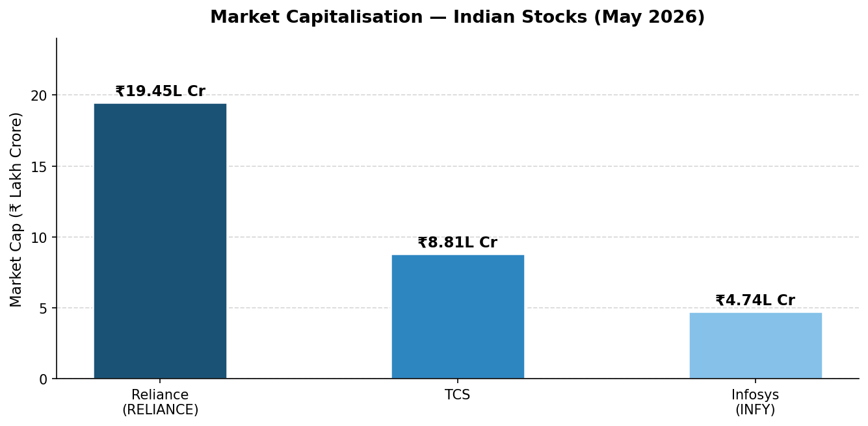
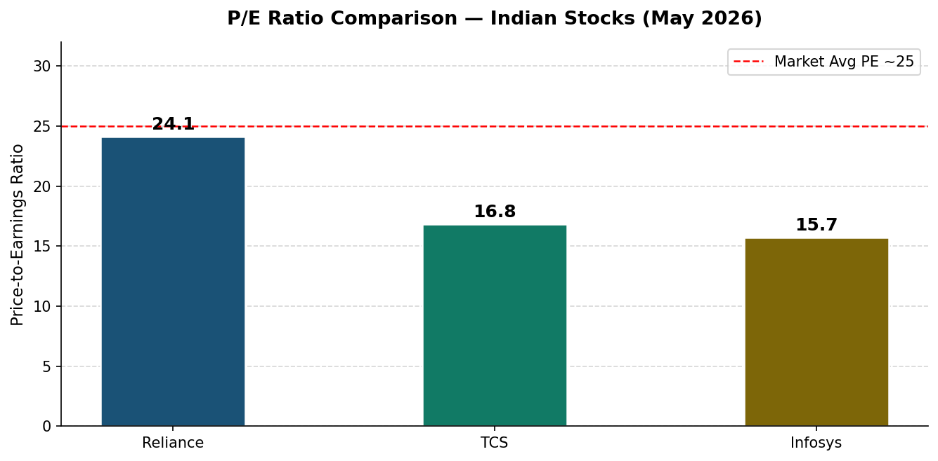
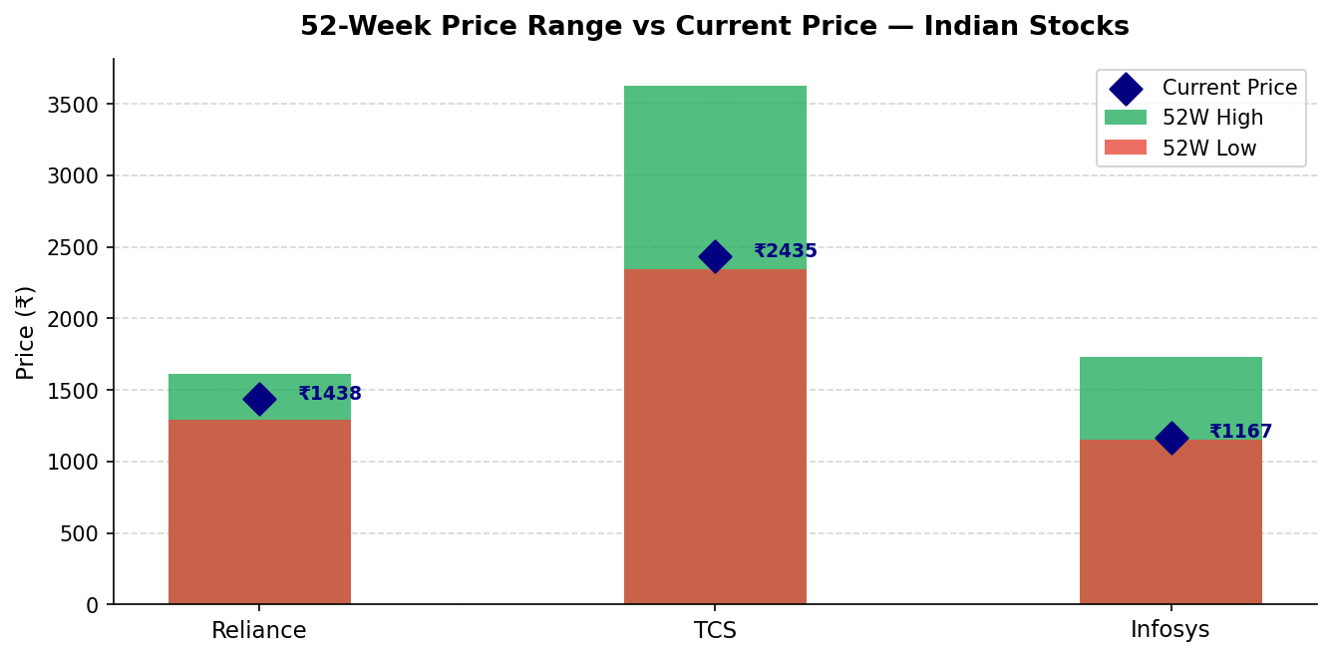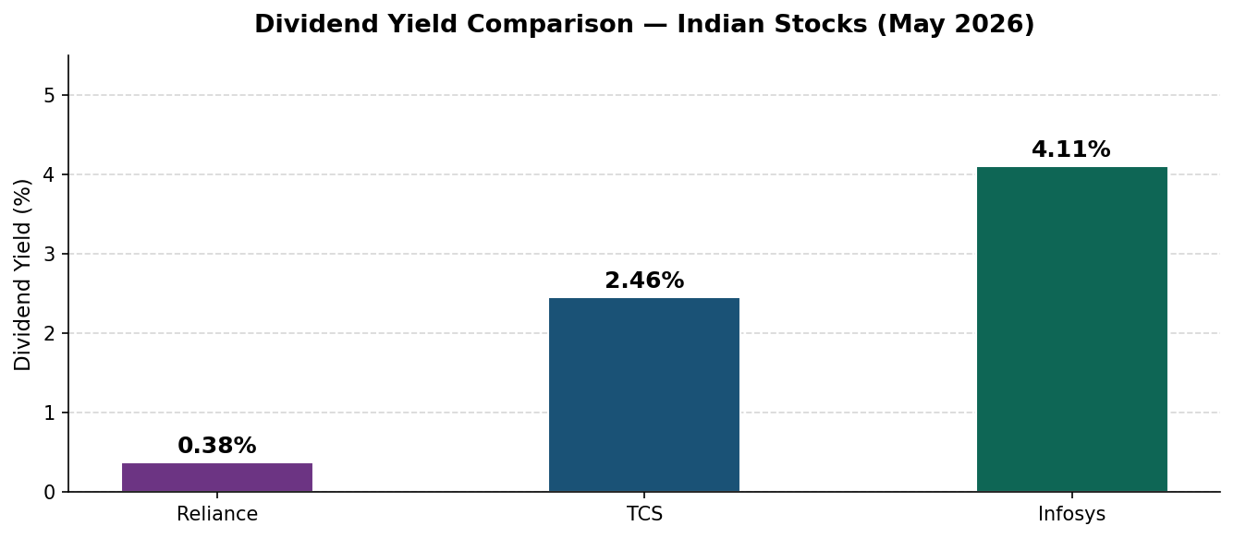
Consolidated Comparison Table
Metric | Reliance | TCS | Infosys
Current Price | ₹1,438 | ₹2,435 | ₹1,167
Market Cap | ₹19.45L Cr | ₹8.81L Cr | ₹4.74L Cr
P/E Ratio | 24.1x | 16.8x | 15.7x
Book Value | ₹668 | ₹296 | ₹229
52W High | ₹1,612 | ₹3,630 | ₹1,728
52W Low | ₹1,290 | ₹2,346 | ₹1,150
Dividend Yield | 0.38% | 2.46% | 4.11%
ROE | 9.25% | 51.8% | 31.9%
ROCE | 10.5% | 63.0% | 40.0%

Conclusion & Recommendation
Stock | Recommendation | Key Reason
Reliance Industries | HOLD | Fairly valued; diversified but modest ROE/ROCE. Good for stability.
TCS | BUY | Historically low P/E 16.8x; exceptional ROE 51.8% & ROCE 63%; near 52W low.
Infosys | BUY | Lowest P/E 15.7x; highest dividend yield 4.11%; strong fundamentals at discount.

